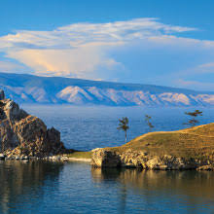**Lake Baikal**

Lake Baikal is the world's deepest and oldest freshwater lake, located in Siberia, Russia.

**History**

Lake Baikal, located in Siberia, is the world's deepest freshwater lake, reaching depths of over 5,387 feet (1,642 meters), and it holds around 20% of the Earth's unfrozen freshwater.